Experiment 7: Transient Response of a 2nd Order Circuit

By:

Shawn Keene, Jason Gilman

Supervisor: Saad Muaddi

Data collected on: 11/06/2019

Due: 11/20/2019

ECEN 214-508, Electrical Circuit Theory

Fall 2019

Prof. Scott Miller

**Procedure:**

Task 1 of the experiment involved building the circuit below. For each case in this task, resistor values were chosen to reach a specific type of response Once the circuit was built the input was set to a 100 Hz square wave, and an oscilloscope was connected to the output and input. After students took screenshots of the waveforms they repeated the task with different resistor values in order to get critically damped, slightly overdamped, over damped, slightly underdamped and underdamped responses.

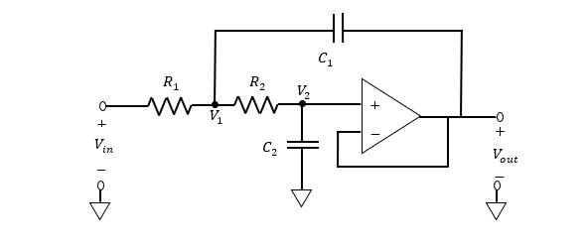

**Data:**

Q = .5 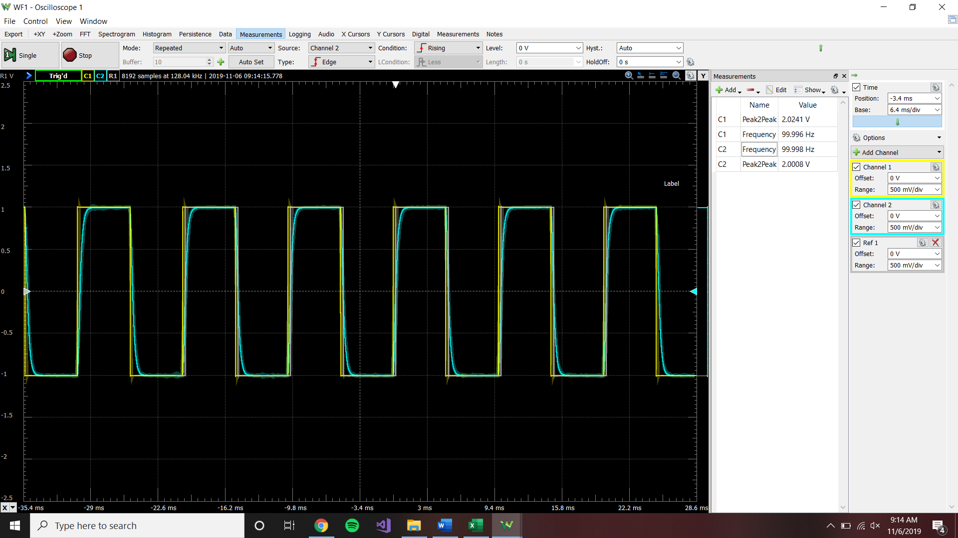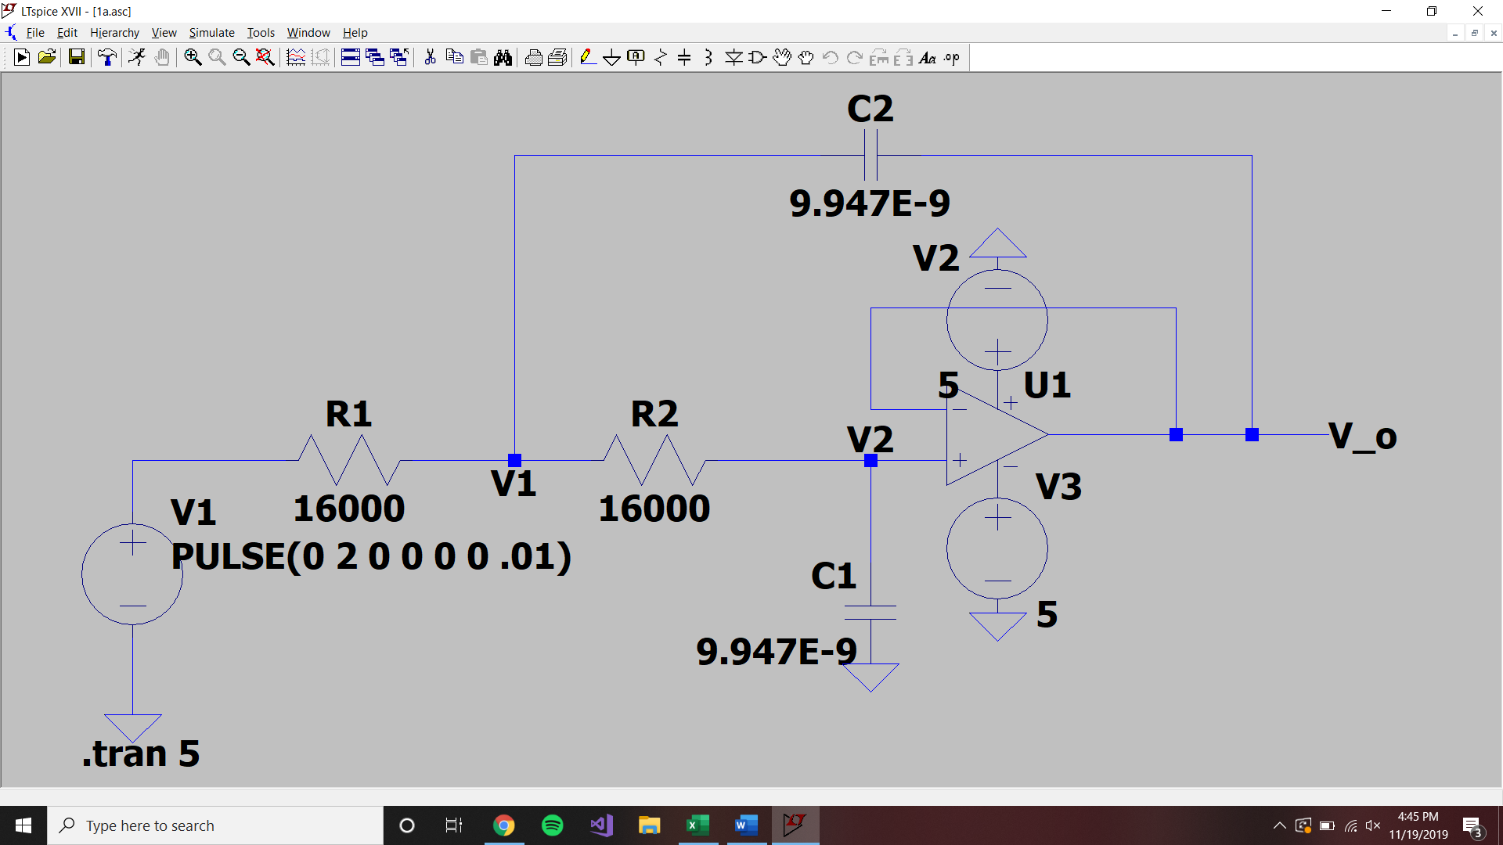

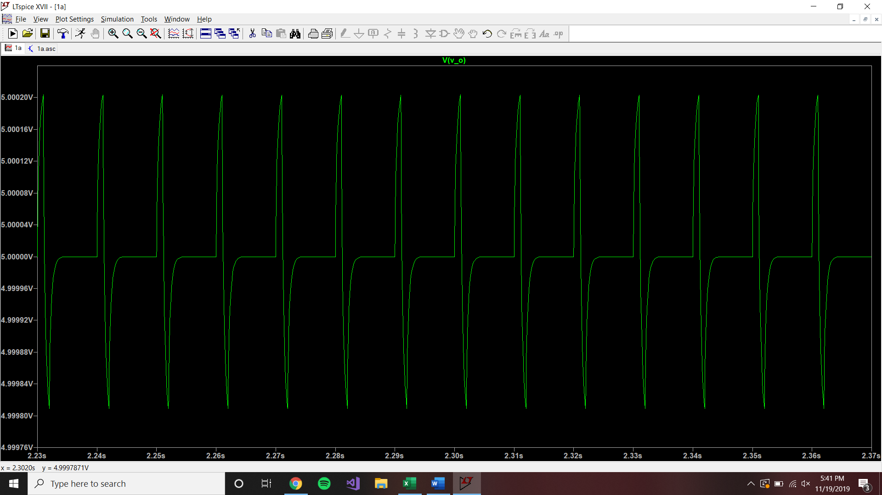

F F Ω Ω

V V Hz

**Theoretical:**

S1=S2=-6600t

Vin(initial)=1

Diffeq:

C1e^-6600t+C2te^-6600t+1

C1+1=0

C1=-1

dv/dt(0)=-6600C1+C2

C2=-6600

Diffeq

e^-6600t-6600te^-6600t +1=Vout

Q = .25

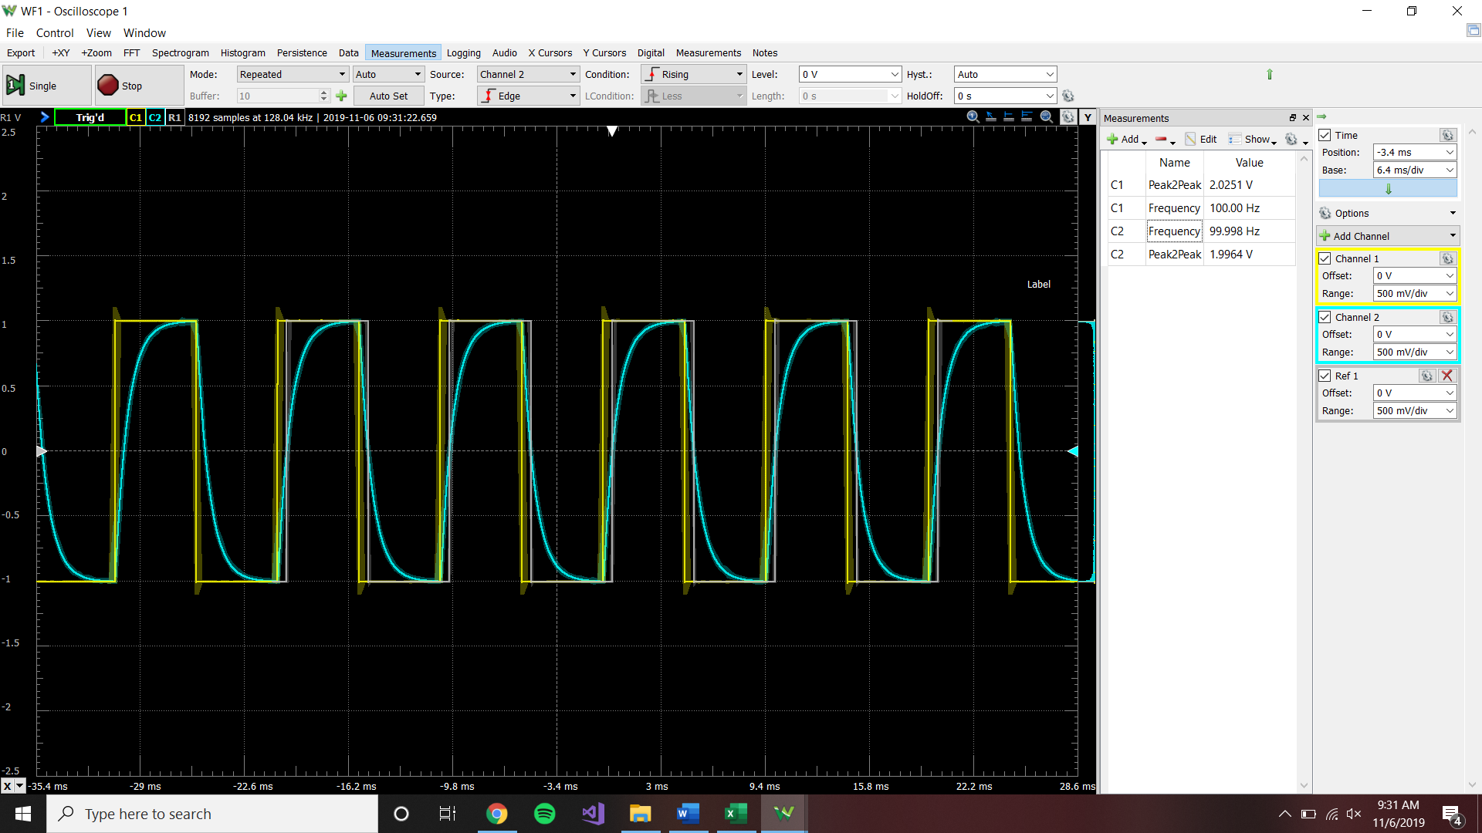

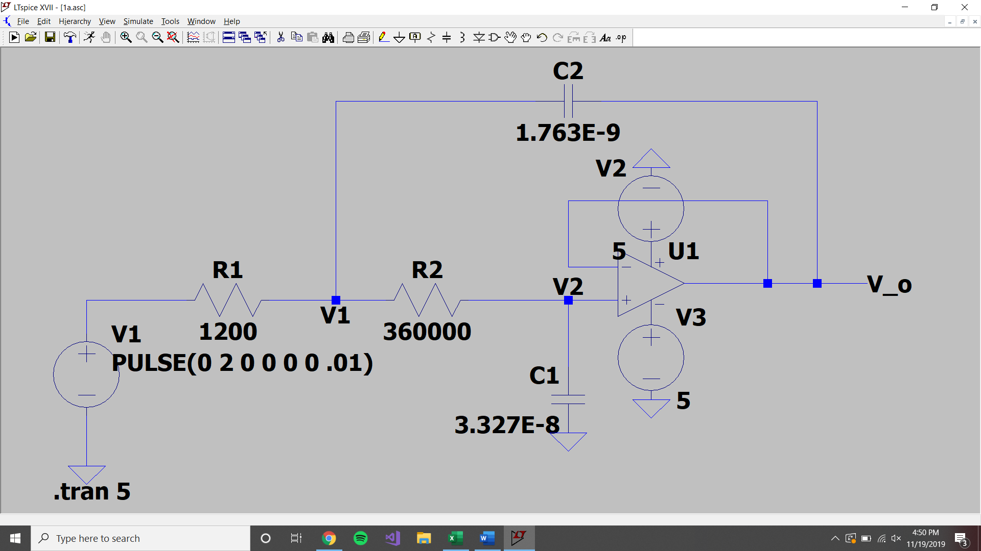

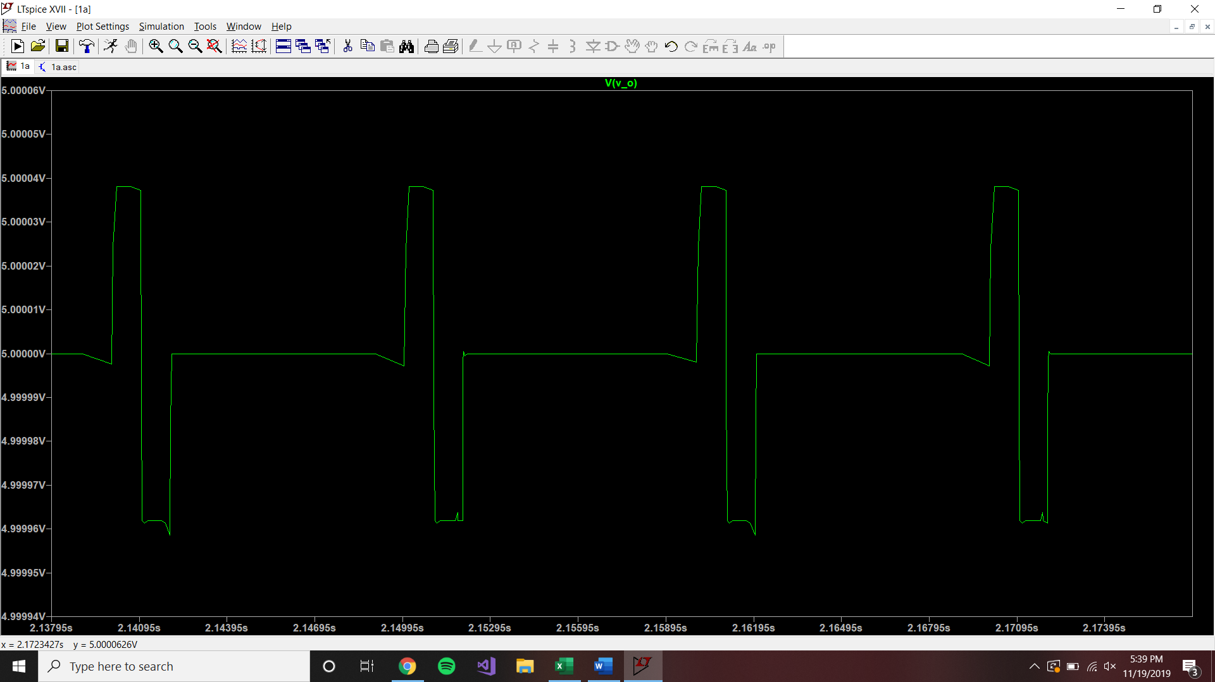

V V Hz

F F Ω Ω

**Theoretical**

S=-6.36*10^-4 +-5.5*10^-4

C1e^(-.0011861t)+C2e^(-8.53*10^-5t)+Y(p)

Initial Vin=1 therefore Y(p)=1

0=C1+C2+1

0=-.001186C1e^(-.0011861t)+(8.53*10^-5)C2e^(-8.53*10^-5t)

C1=.0775

C2=-1.077

Diffeq

.077e^(-.01186t)-1.0775e^(-8.53*10^-5t)+1=Vout

Q = 1

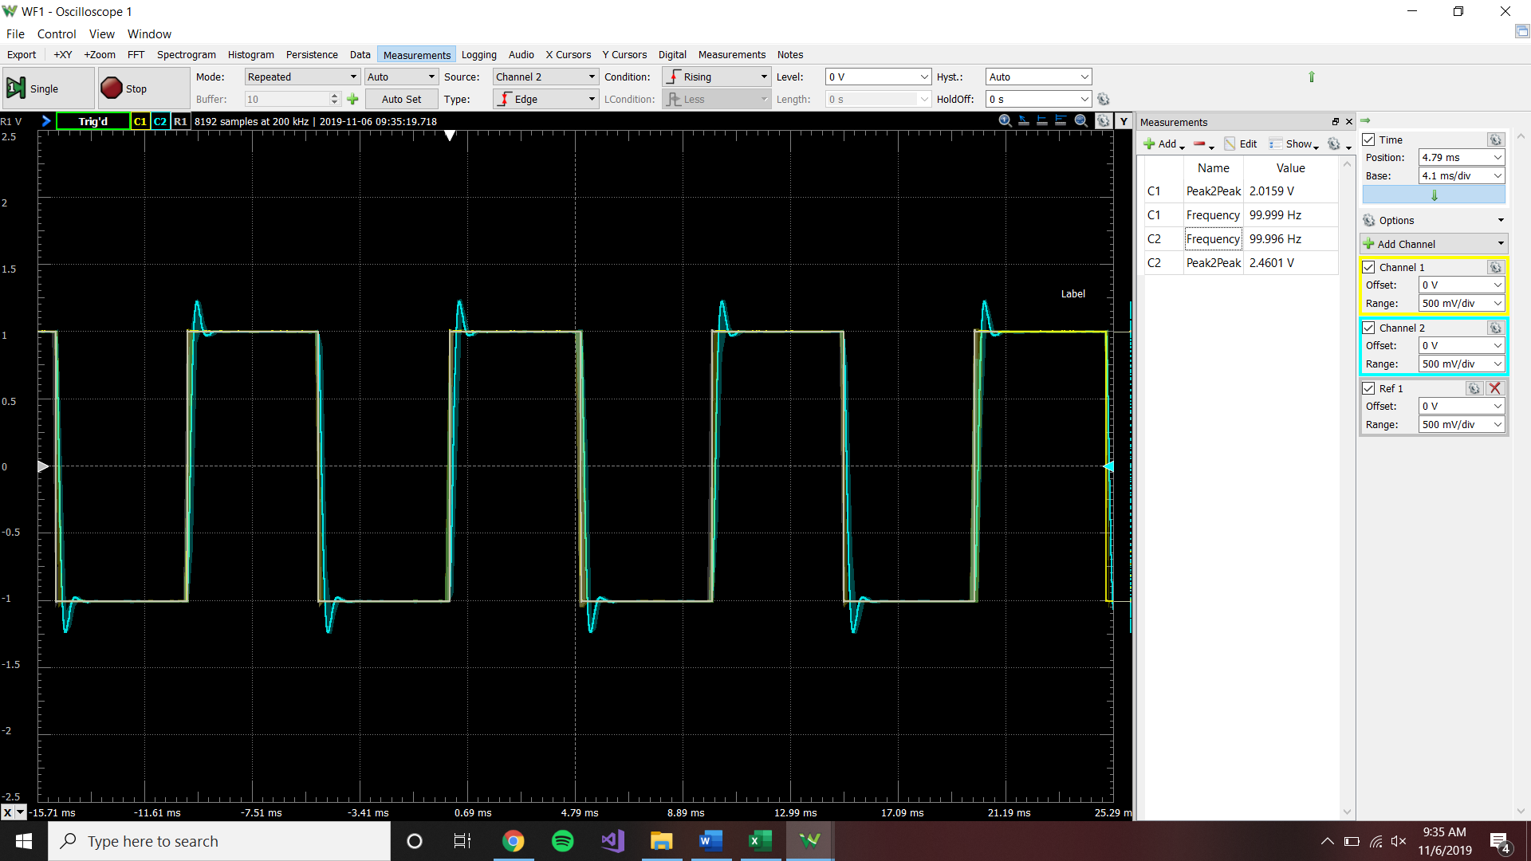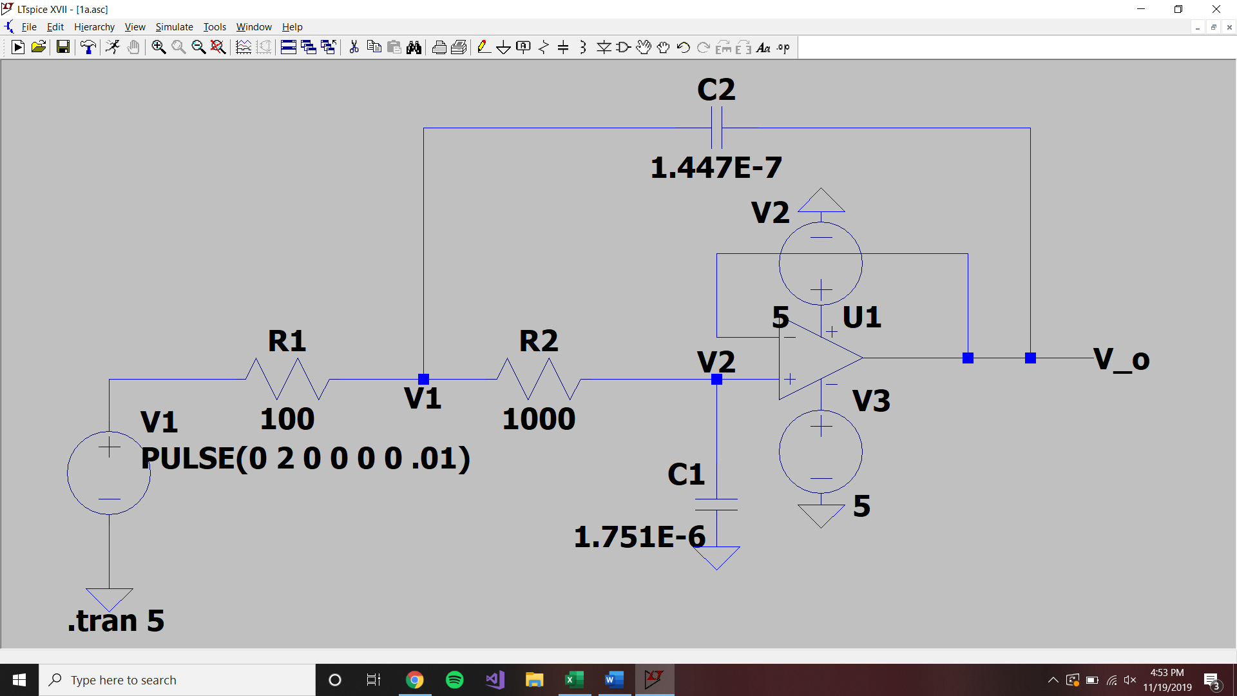

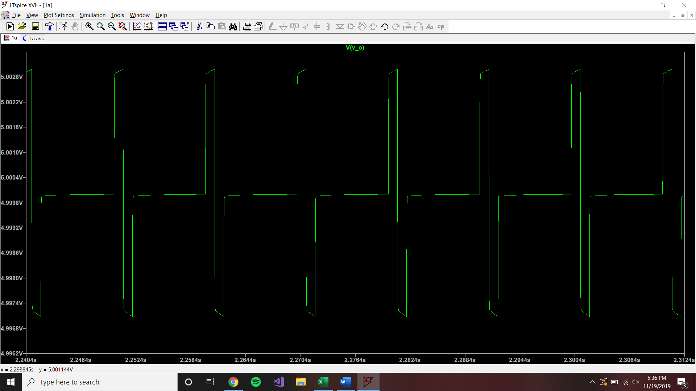

V V Hz

F F Ω Ω

**Theoretical:**

S=-1.59*10^-4 +- .0125

C1e^(.01244t)+C2e^(-.012759t)+1=0

.01244C1e^(.01244t)-.012759C2e^(-.012759t)=0

C1=-.506

C2=-.4936

Diffeq

-.506e^(.01224t)-.4936e^(-.012759t)+1=Vout

ERROR! Should be in the form of C1e^a*cos(Bt)+C2e^a*sin(Bt). Fixed this mistake in demo of lab.

Q = .1

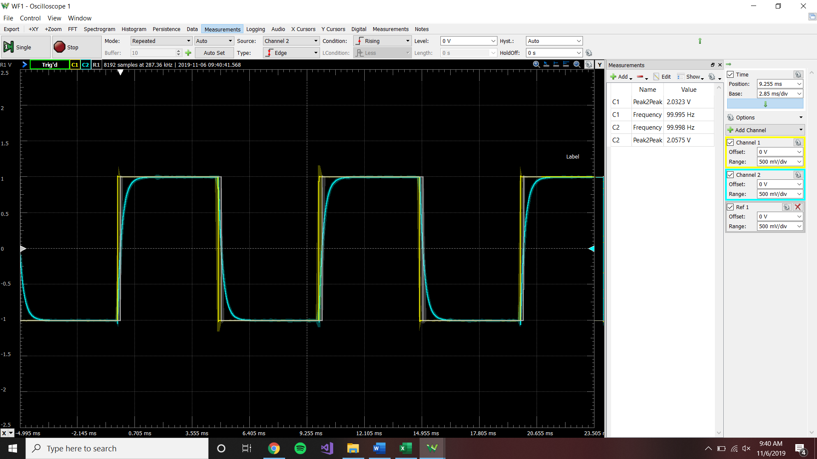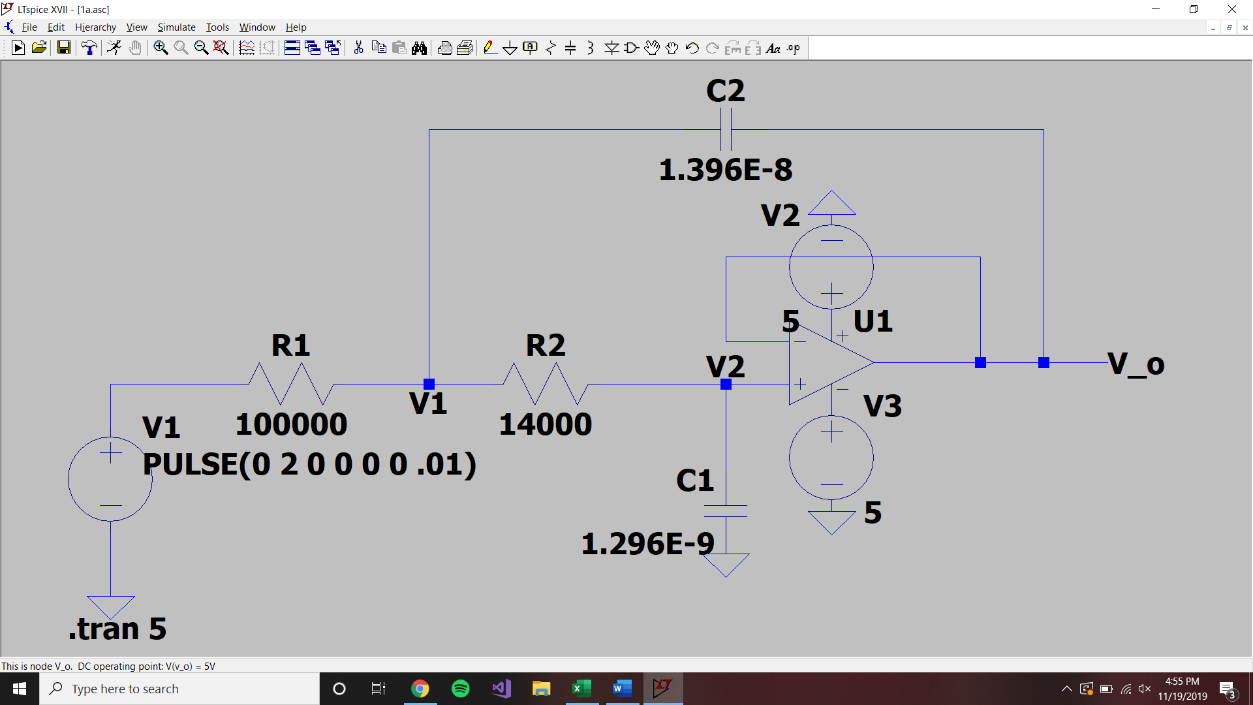

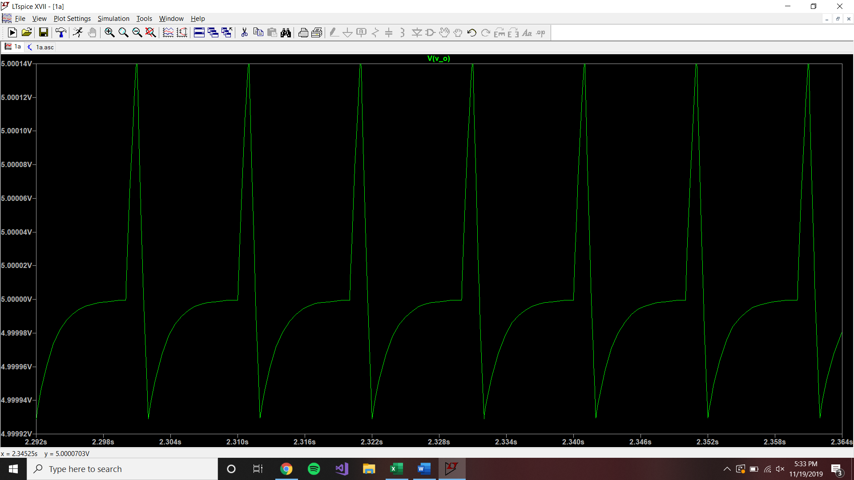

V V Hz

F F Ω Ω

**Theoretical:**

S=.00159+- .00155

C1e^(-.00315t)+C2e^(-3.07*10^-5t)+1=0

C1+C2=-1

-.00315C1-3.07*10^-5C2=0

Diffeq

.0098e^(-.00315t)-1.009e^(-3.07*10^-5t)+1=Vout

Q = 2.5

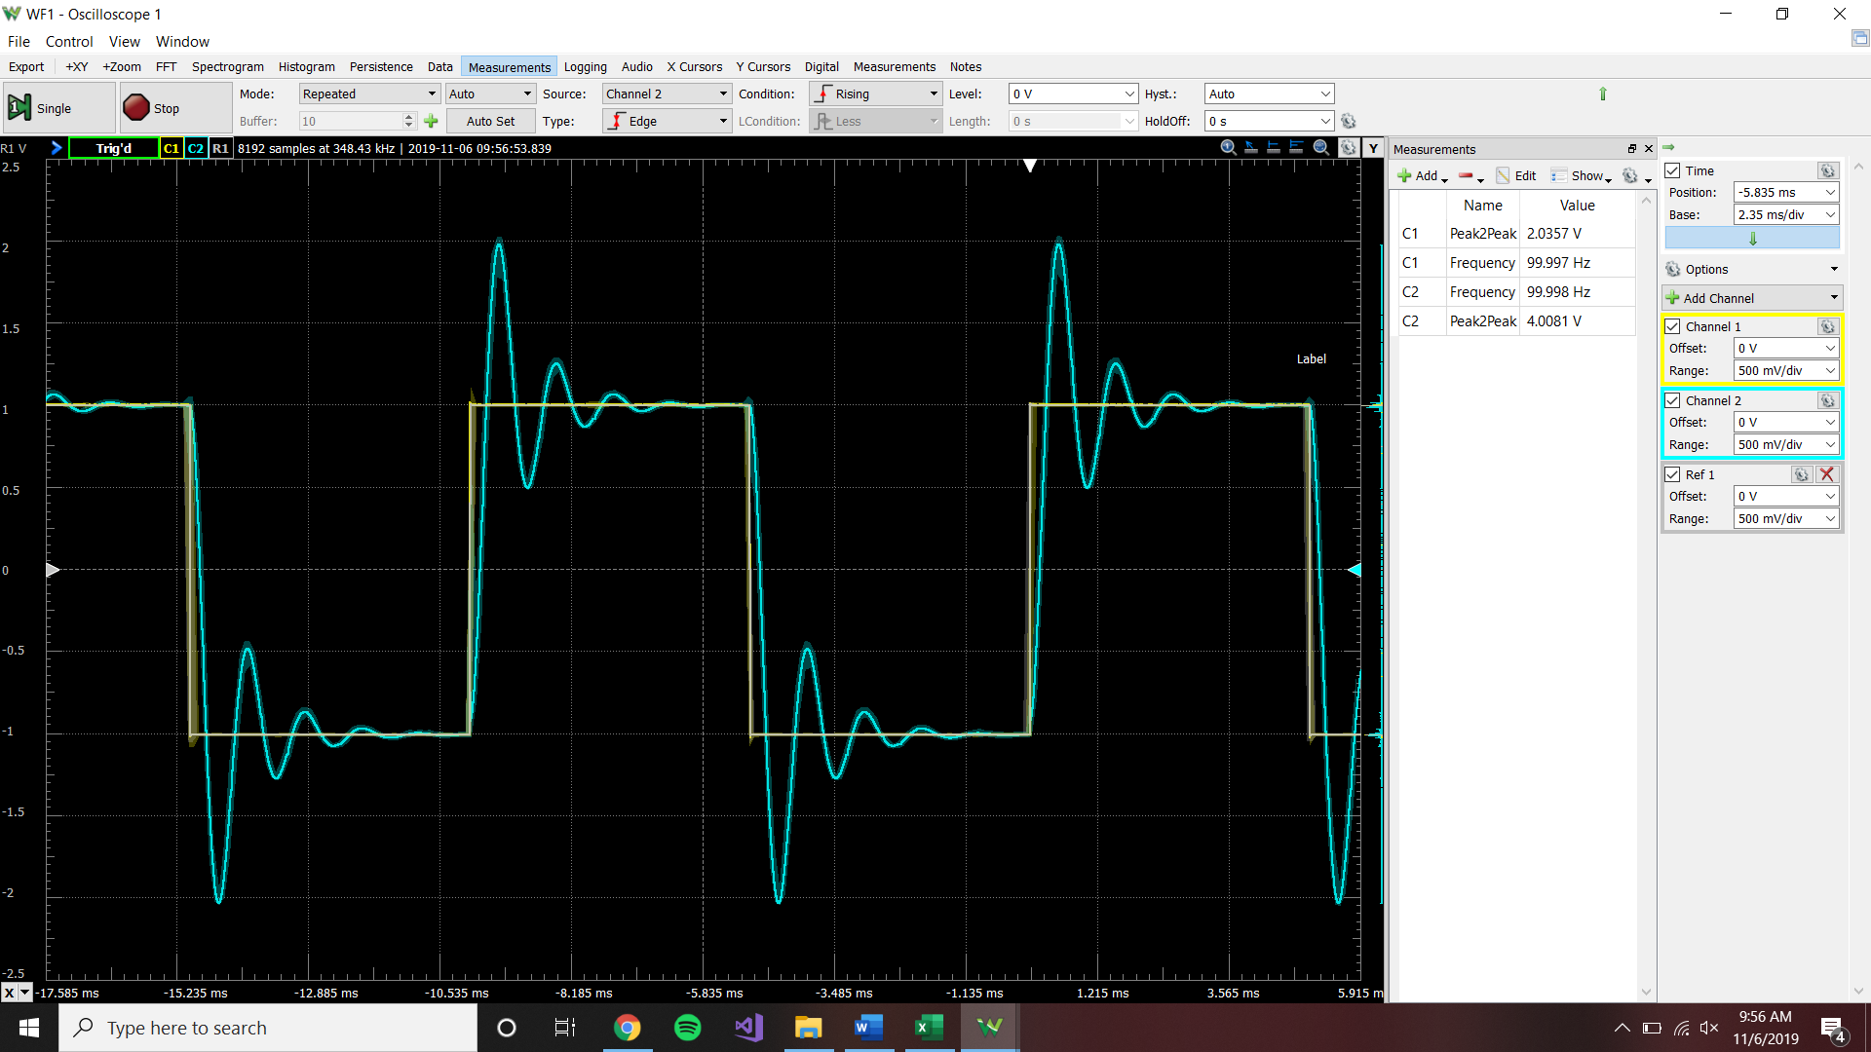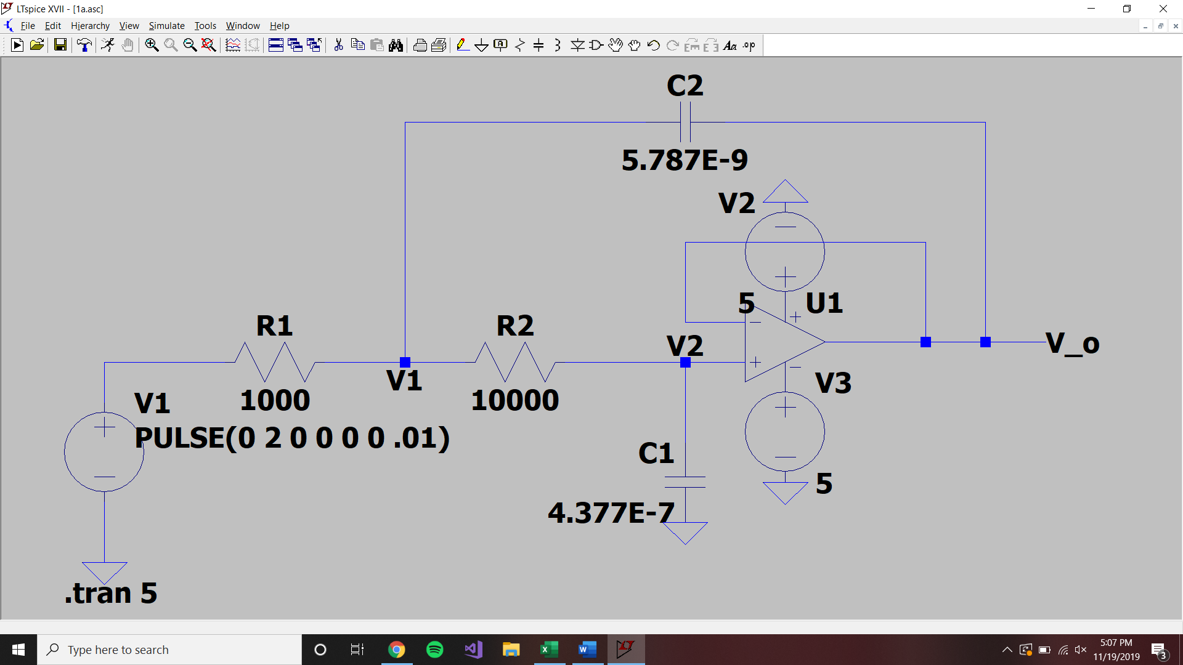

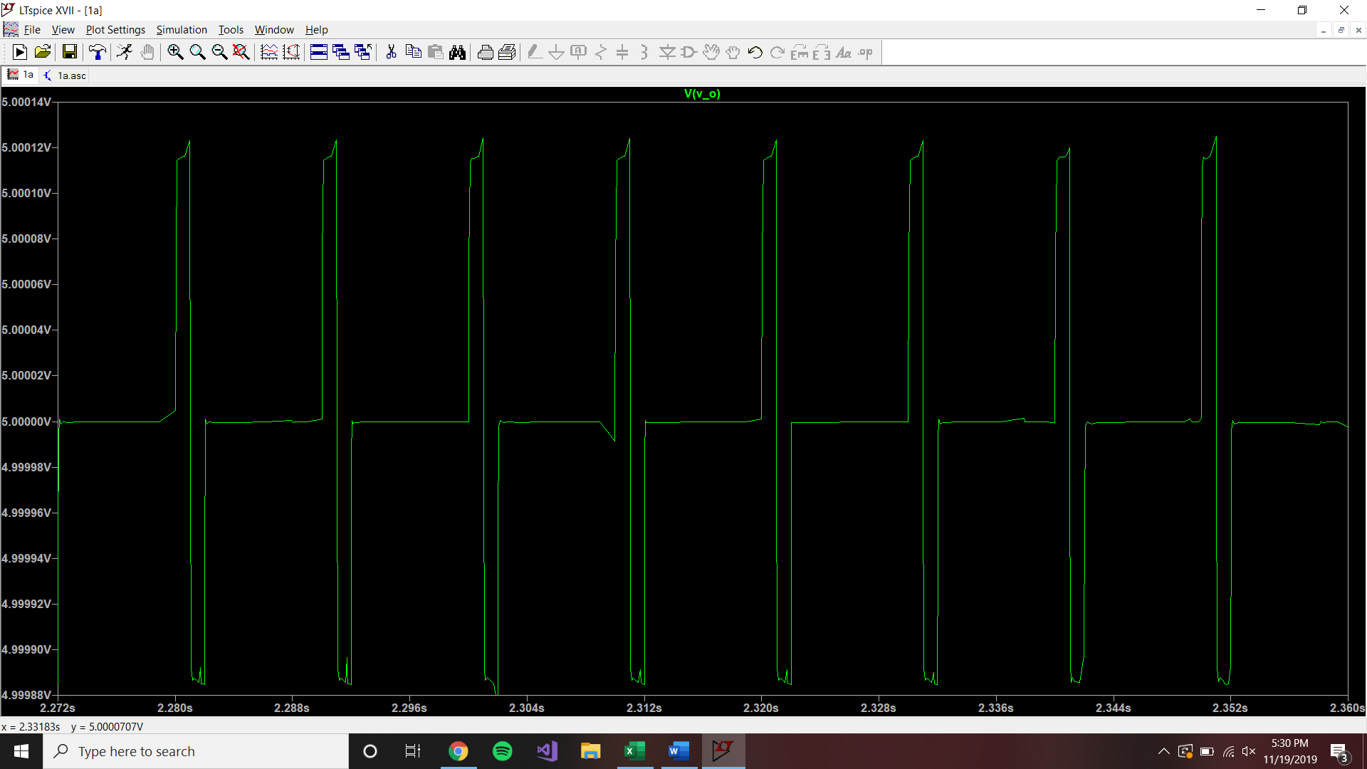

V V Hz

F F Ω Ω

**Theoretical**

S=-6.35*10^-5 +- 3.1188j

C1e^(-6.35*10^-5t)cos(-3.1188)+C2e^(-6.35*10^-5t)sin(-3.1188)+1=0

C1=-1

C2=2.042

Diffeq

-e^(-6.35*10^-5t)cos(-3.1188)+2.042e^(-6.35*10^-5t)sin(-3.1188)+1=Vout

**Discussion:**

The main variables, that are subject to change, that would make the results better are the values of the 2 resistors and capacitors that are in the sallen-key circuit. By changing around the values of the resistors, R1 and R2, in the equations:

C1 = (Q/⍵)*((1/R1)+(1/R2)) C2 = 1/(⍵*Q*(R1+R2))

If better combinations of resistors were used, the resulting capacitor values would be closer to the ones that exist in the lab kit.